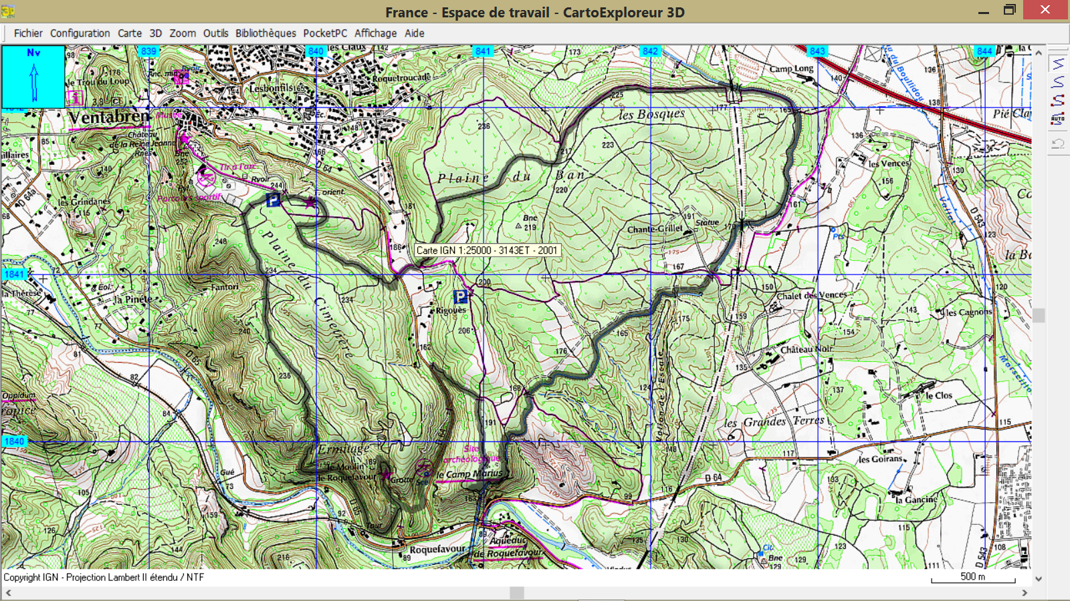

**GR3 Distance 14.5 Kms Dénivelé + 240 M**

D/A AA