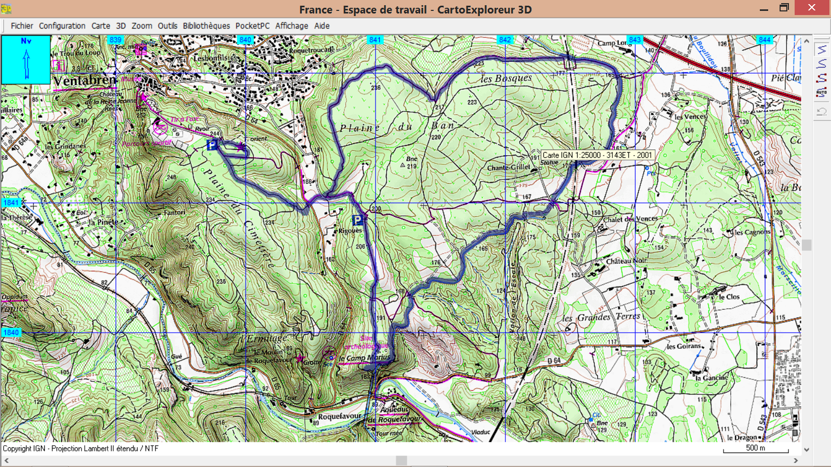

**D/A**

**GR2 Distance 11.5 Kms Dénivelé + 200m**