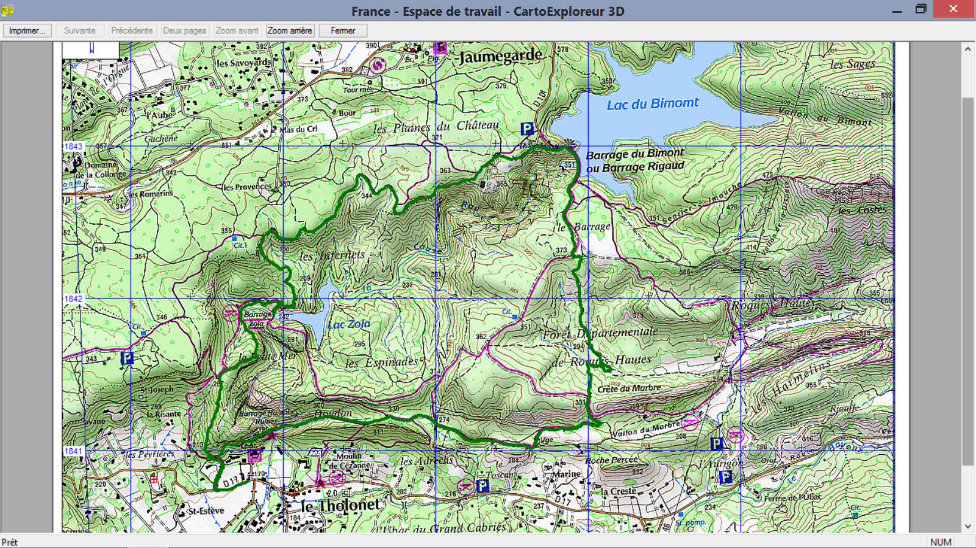

D/A

G1 Distance 12Kms et 350 Metres positifs